5.import java.util.Arrays;

class Main
{
public static void swap(int[] arr, int a, int b)
{
int temp = arr[a];
arr[a] = arr[b];
arr[b] = temp;
}

public static void bubbleSort(int[] arr, int x)
{
for (int a = 0; a < x - 1; a++) {
if (arr[a] > arr[a + 1]) {
swap(arr, a, a + 1);
}
}
if (x - 1 > 1) {
bubbleSort(arr, x - 1);
}
}

public static void main(String[] args)
{
int[] arr = { 7,53,65,-83,-45,9,34,-20 };

bubbleSort(arr, arr.length);

System.out.println("Author:J.GOPI VENKATA SAI\nSAP ID:51834677");
System.out.println(Arrays.toString(arr));
}
}

OUTPUT:
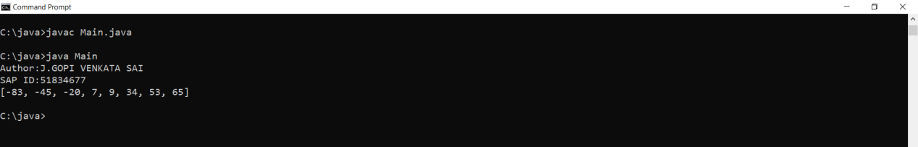

2.import java.util.*;

public class Main {

public static void main(String[] args) throws Exception {

Scanner sc = new Scanner(System.in);
System.out.println("Author:J.GOPI VENKATA SAI\nSAP ID:51834677");
System.out.println("Enter the first string:");
String input = sc.nextLine();

System.out.println("Enter the second string:");
String rotation = sc.nextLine();

if (checkRotatation(input, rotation)) {
System.out.println(input + " and " + rotation
+ " are rotation of each other");
} else {
System.out.println("they are not rotation of another");
}

sc.close();
}

public static boolean checkRotatation(String original, String rotation) {
if (original.length() != rotation.length()) {
return false;
}

String concatenated = original + original;

if (concatenated.indexOf(rotation) != -1) {
return true;
}

return false;
}
}

OUTPUT:
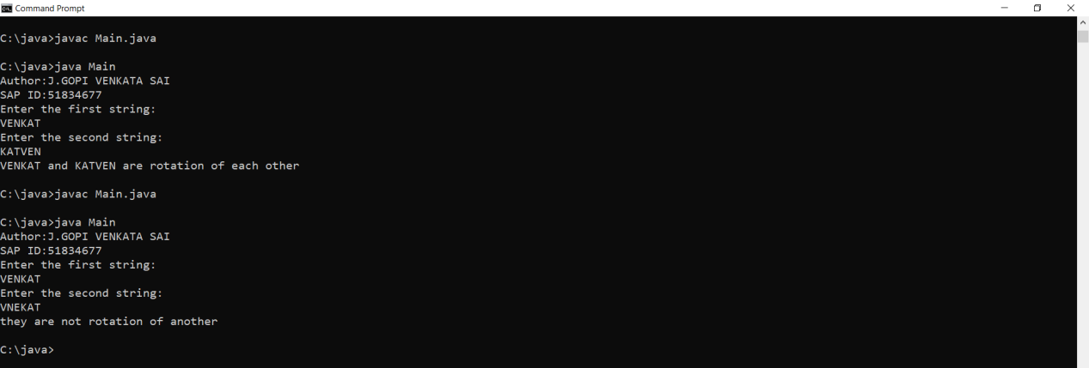

3.import java.util.Scanner;
class Main
{
public static int[] replaceNum(int num,int length, int num1)
{
int d[]=new int[length];
for(int i=0;i<length;i++)
{
d[i]=num%10;
num=num/10;
}
for(int i=0;i<length;i++)
{
if(d[i]==num1)
{
d[i]=10;

}
}
return d;
}
public static int length(int num)
{
int length=0;
int temp=num;
while(temp>0)
{
temp=temp/10;
length++;
}
return length;
}
public static void main (String[] args) {
Scanner sc=new Scanner(System.in);
System.out.println("Author: J.GOPI VENKATA SAI");
System.out.println("SAP ID: 51834677");
System.out.print("\nEnter a number: ");
int n=sc.nextInt();
System.out.print("Enter a number to removed: ");
int num1=sc.nextInt();
int length=length(n);
int[]d=replaceNum(n, length, num1 );
System.out.println("\nNumber after the digit is removed...");
for(int i=length-1;i>=0;i--)
{
if(d[i]<10)
System.out.print(d[i]);
}
}
}

OUTPUT:
